**P4 – Explain the functions of network management**

**Introduction**

In this assignment, I will be explaining the functions of network management. The functions include:

* *Configuration, fault management, account management, performance management, user response time, planning, designing, installing, security, data logging, checking performance, reporting.*

**Configuration**

Configuration is a vital part of the infrastructure. This configures IP addresses enabling other users to access the site. Having access to the site is vital to complete work for the organisation. Removing distracting websites will be important for the user for it to complete work for the organisation.

**Fault management**

Fault management is a process when it manages all of the faults in a network. These faults can be to detect, correct or isolate any malfunctions in a network. As this is a fault management, you can expect it to deal with any situation that the network comes across. The management allows the order to put the major to minor issues to be resolved. This is a clever technique as it allows the network to clear the major problem first and then the minor issue. There is a list full of what fault management does. They are two types of fault management; and they are passive and active. Passive does all the alerting work. Once they are alerted, they pass it on to active, which does the entire job. This could require blocking any unauthorised access to a person. This could be a fault. If the passive fault management does not alert, it will not detect any sort of trouble that is sorting the network. This is the whole purpose of the fault management. This system does all the blocking, detecting and correcting of the management.

**Performance management (PM)**

The purpose of the performance management ensures whether the goals have been met or not. This is important for fault management because if it has not been alerted, performance management will check if the performance of the whole system is running accurately. If it is not running accurately – something is wrong – this will mean that others will be alerted to check it out. In addition, they are other softwares that will make sure the performance of the system is running fine. This could solve many issues that sometimes is not detected. The user can tell whether something is wrong with the performance. This is because they are using the system. They could tell whether it is slow, or some app is not working properly as usual. The user can scan the computer to get rid of any malware of the system to get it faster.

**Account Management**

Account Management refers to the manager of the accounts. It is a person who deals with all the usernames and passwords if they are forgotten it or it has been locked. As he has created these accounts for the students/employees, it can overlook who is currently using the account and who is not using the account. This is the basics of the account manager. For example, in LSC, username and passwords are given to students to give access so they can complete coursework. One of the biggest disadvantage of giving out username and password is that students can change their password and forget it. They have to keep going to ‘technical support’ so they can unlock or reset the password to gain access again. The problem is that if ‘technical support’ people are not there, they have to wait until it is complete. As the manager is in charge of the account, he needs to make sure that the user has everything he needs to access. They are a number of information he needs:

* Internet – specific websites
* Printing
* Email account
* Username and password details
* Specific softwares he needs on the program
* Able to change the password

These are important for any organisation. If these are not, the employee/student cannot complete the work without it. The software is important for the user. If he has an account and he does not have Microsoft Word, the user would need to purchase Microsoft Office and download it onto the account. This is time-consuming for the employee and he is losing time to work. Time is important is business and for any organisation. Having an ICT technician within the organisation is important would improve the security for the accounts that are made. Another benefit is that the account management has the power to remove accounts. This is important if the any employee is redundant. If they did not, users would not understand and especially for new users. This is useful for the business because for security purposes. Security is one of the main priorities for businesses. It is important they would need to look at the security aspects of it as my business would.

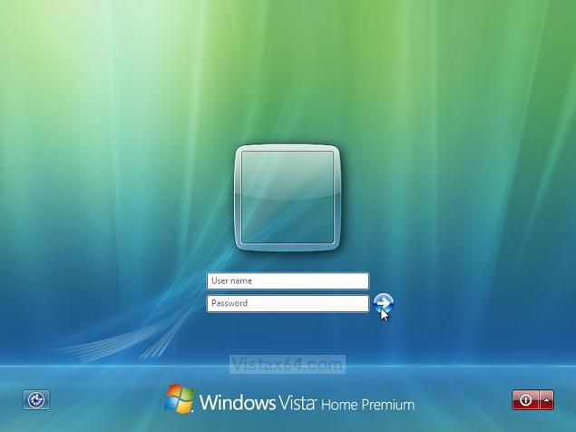

**User response time**

This is how long the user takes to tell a technician that there is a problem with their computer, and the slower they tell them, the slower the problem will be resolved. Also, the faster they tell them, the less problem. This is all about the response time. The longer the user takes time to tell the technician, the result could be massive. For example, if a virus is on the computer, it could potentially harm the system dramatically and quickly. The user needs to detect that is has a virus and needs to tell an IT expert what to do. They will advise them and it would be all sorted out.

**Planning**

Planning a network is important to know the availability of the space. Without planning, it would go all wrong. The planning stage takes a while to do. Any person has to look at the benefits and drawbacks of the network. This stage, the user can pick out whether to continue with the project or not. The user needs to know the correct amount of space to put the computers in one room. The user needs to know how big the room is for the network to connect. For example, if the room were big, the user would put computers in that fit the room. Our LSC class contains around 19-20 computers, which connects all the computers together. It gives a clear understand, not only the space, of which topology to use and how much to spend. Planning includes the start of the project. This includes to maintaining it, the budget and all the other factors that go with it.

**Designing**

Designing the whole network could be simple or complicated depending on the topology structure. If it were basic like bus, the user would know what to do. For example, have a base and put the computes. However, if the building is structured differently, they need to figure out the perfect way to figure out the topology. Some are hard to do.

**Installing**

Installing the network is the actual work. This is implementing the ideas that they have came up with and doing the work. This is after all the planning and pre-designing stage of the whole process. Installing the network would take quite a long time depending on who is building it. This is because people take time and building a network is long, around 4-5 months roughly. It is highly likely that mistakes would pop up, but it is advised that they do not make those mistakes whilst installing the network. This is because it would take even longer for the people to install the network. Not only physical work, but the whole computer to be set up takes long.

**Security**

Securing the network is one of the biggest factors that needs to be maintained out of the entire network, not mentally (within the computer), but physically. The user can use many softwares that the user can use to protect the inner layer of the network. For example, if any malware enter the network, the anti-virus would need to act fast enough for the malware not to make damage. Essentially, the anti-virus removes it and removes any highly virus that enters the user. In addition, if any person is trying to enter the network, it is blocked, as there is a password for the user to enter. Without the unique password, the user cannot enter the password.

**Data logging**

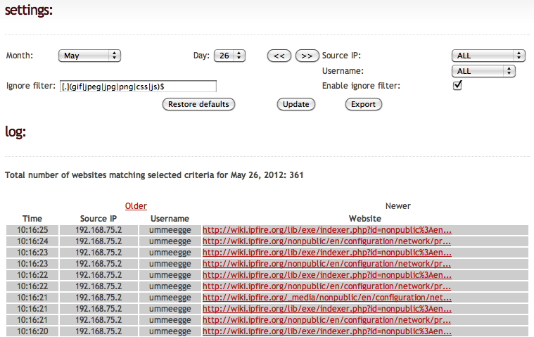Data logging is gaining information through sensors and any other results of where data logging is used. Once the data is complete, the user analyses the results and if any problems occur, it can be shown and the problem is erased. For future references, it is beneficial as it would become a bigger problem, and it would cost more than it usually was. It is called ‘logging’ as it recalls and records all of the issues that the network has faced so far. As the picture shows, the user can see what time, month and day of what the user used. This is effective as the user could be reminded of what to use and how to use it appropriately.

**Checking Performance**

Checking the performance is maintaining the network. It is always important that you monitor the network. This is to ensure that the network is not misbehaving or any viruses have entered the network. If they keep up monitoring the network, the network would not have to deal with any errors and issues. Sometimes, without notice, the network would have to deal with blocking unauthorised access every day. The main advantage is that if you monitor the network, it detects any mistakes and errors. In addition, it makes the network much faster. If a specific node slows down the network, the user can detect it and fix the problem for the network to run faster. Some topologies rely on one computer. If that computer does not work, the whole network would not work and if a virus is entered within the network and is not picked up by the software; it could affect the whole network.

**Reporting**

Reporting the any problem is essential. As maintaining the network, it could affect the whole network if it has not been picked up, it could damage and lose any files from it. When reporting it, packets are sent off notifying the technician of the problem. This is essential to any network. Reporting and notifying the technician solves any costs from the organisation. This is because, again, if the problem is delayed, it could cost the company money to fix if not fixed by the technician. This reports to the technician straight away and the benefit is that the technician, once known about the problem, can fix the issue straight away.